IN1002 Cryptography Coursework By Francis Obioha Agwanihu
In this report, I will be discussing 4 algorithms within Number Theory and Cryptography in ascending difficulty. I will research and give both high-level and technical explanations for each algorithm. I will justify their need as well as give an analysis and justification for their time complexities. Finally, I will implement the 4 different algorithms, annotating and commenting each line. The algorithms include Euclid’s GCD Algorithm, The Sieve of Eratosthenes, The Modular Exponentiation Algorithm and The Diffie-Hellman Exchange Algorithm.
Algorithm 1: Greatest Common Divisor (Euclid’s Algorithm)
The algorithm itself works by stacking repeated subtractions atop one another, specifically (largest – smallest = difference). This begins with our initial values a and b as inputs into the algorithm, taking a > b. We take the difference between a and b to get (a – b).
a – b = (a-b)
We then replace the larger number with (a – b) and take the difference between the larger and smaller again:
a = (a – b), b = b

(a – b) – b = (a – b – b)

This continues until doing (a – b) = 0, upon which GCD = a = b.

- The algorithm has a few preconditions, firstly, a and b must both be integers, real numbers break the algorithm fundamentally due to floating point errors. Secondly, a and b cannot both be 0, because every number divides 0, meaning there is no greatest divisor because a larger number can always be named.
For postconditions, the algorithm will output a value g that divides a and b, and there exists no number greater than g that divides both a and b.
- The basis of Euclid’s Algorithm is a well-established axiom. Taking 2 integers, a and b, the greatest common divisor (GCD) of a and b, we will call g, divides not only a and b evenly, but also their difference, (a – b). So,

GCD of a and of b = GCD of (a-b).
This can be proven mathematically, assume
a = (g×m) and b = (g×n)
(where g is the GCD between a and b, m and n are some integers multiplied to give a and b respectively).

Doing a – b gives us:
(a – b) = (g × m) - (g × n).

Factoring out g we get:
(a-b) = g(m – n)

meaning the GCD also divides (a-b). This sets the foundation for the rest of the algorithm.
Because of the axiom above, a and b’s GCD is shared by their difference, (a – b). This property is being carried on to the next subtraction of the algorithm, meaning, transitively, the GCD shared by (a – b) and b is shared by their difference (( a – b )– b) , just as it was for a, b and (a-b). This property is preserved through each step of subtraction and so, this idea holds all the way till (a – b) gives 0. At the point where (a – b) gives 0, a = b. The GCD of a single given number and itself is always going to be itself (gcd(x, x) = x). Since this final set of integers, a and b, have the same GCD as every set before them up to our initial numbers (due to the aforementioned preserved GCD), we can take their GCD to be the output of our algorithm, solving the problem.

This same idea works for using the modulus operator (mod), gcd(a, b) == gcd(b, a mod b). This is because of the way modulus functions, under the hood, modulus is the same kind of repeated subtractions as what the algorithm performs. a mod b finds the amount left over of trying to fit b into a as many times as possible without going over. It does this by taking b away from a q times, where q is the amount of times b fits into a cleanly:
a mod b = a – b – b – b – b -b… = a – bq

We can see that applying a modulus rather than pure subtraction is condensing multiple subtraction steps into a single operation. This is why using modulo instead is both faster and preserves the GCD, in each of the condensed subtractions the GCD is preserved, therefore, repeatedly applied modulus operations will reach the same goal, except faster.
- Java Implementation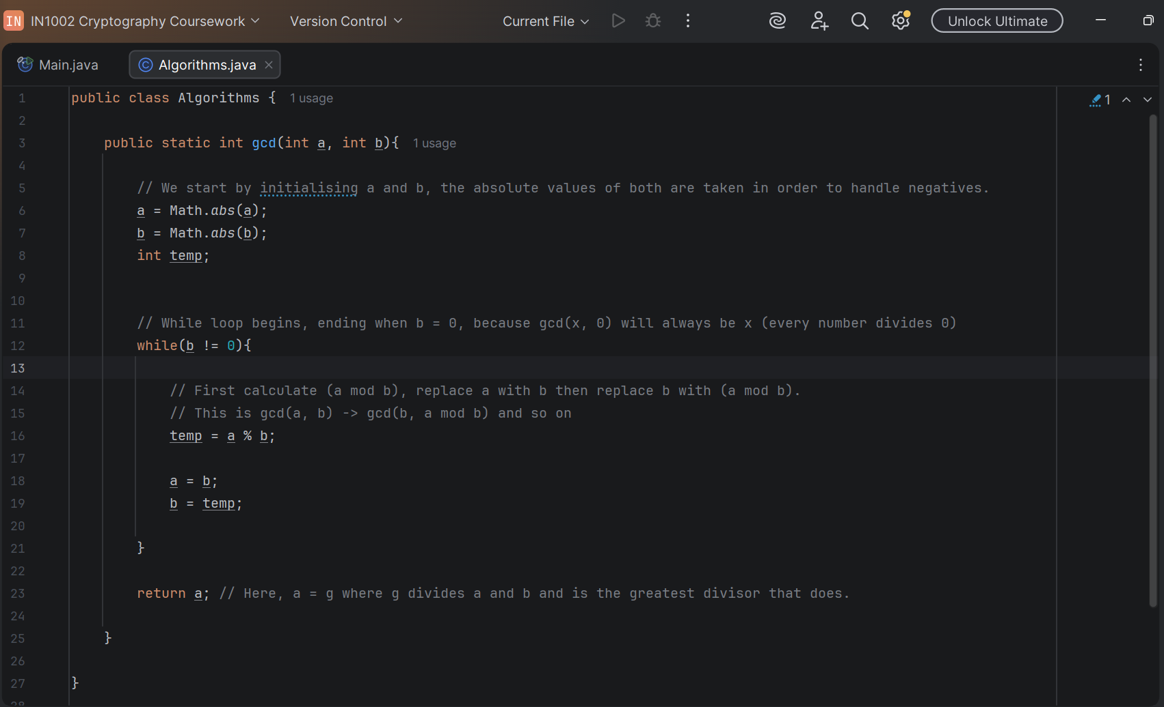
- Testing
Test 1
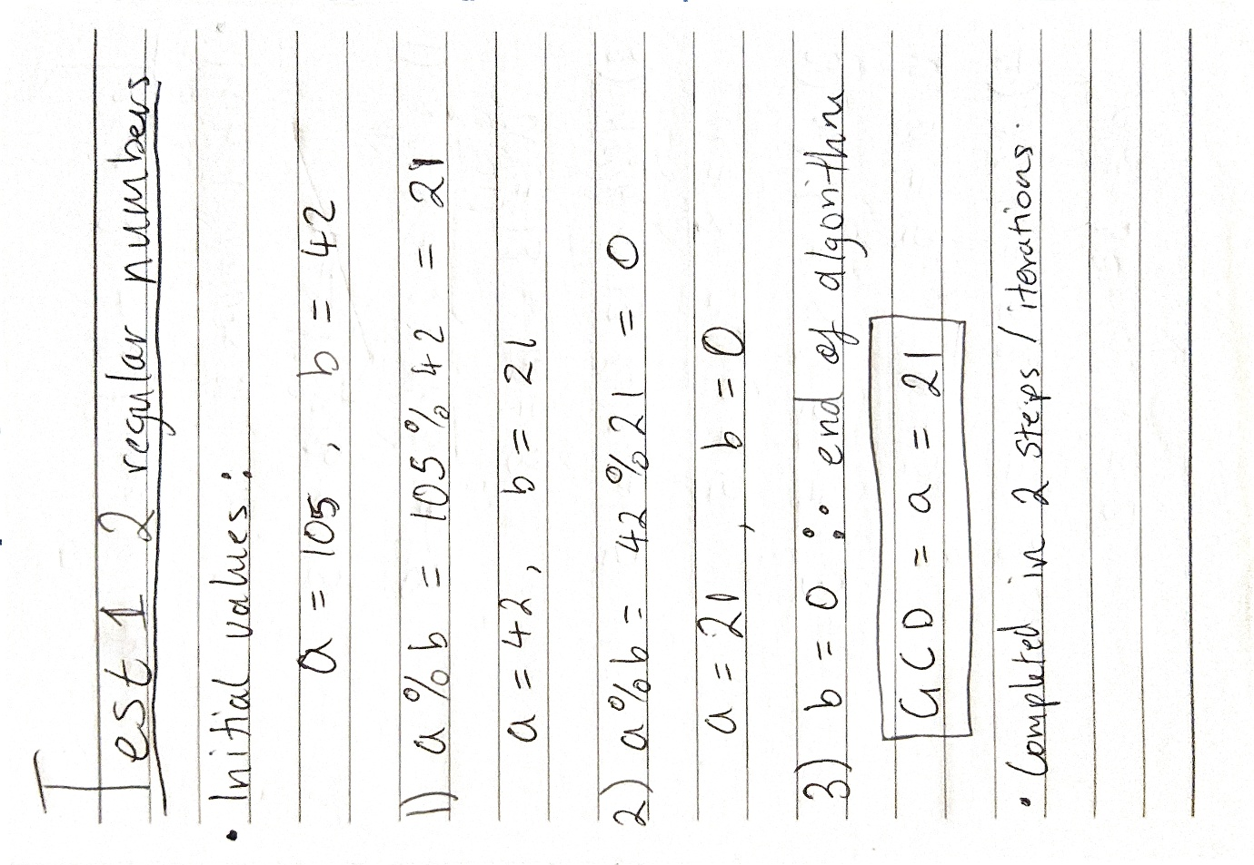
Test 2
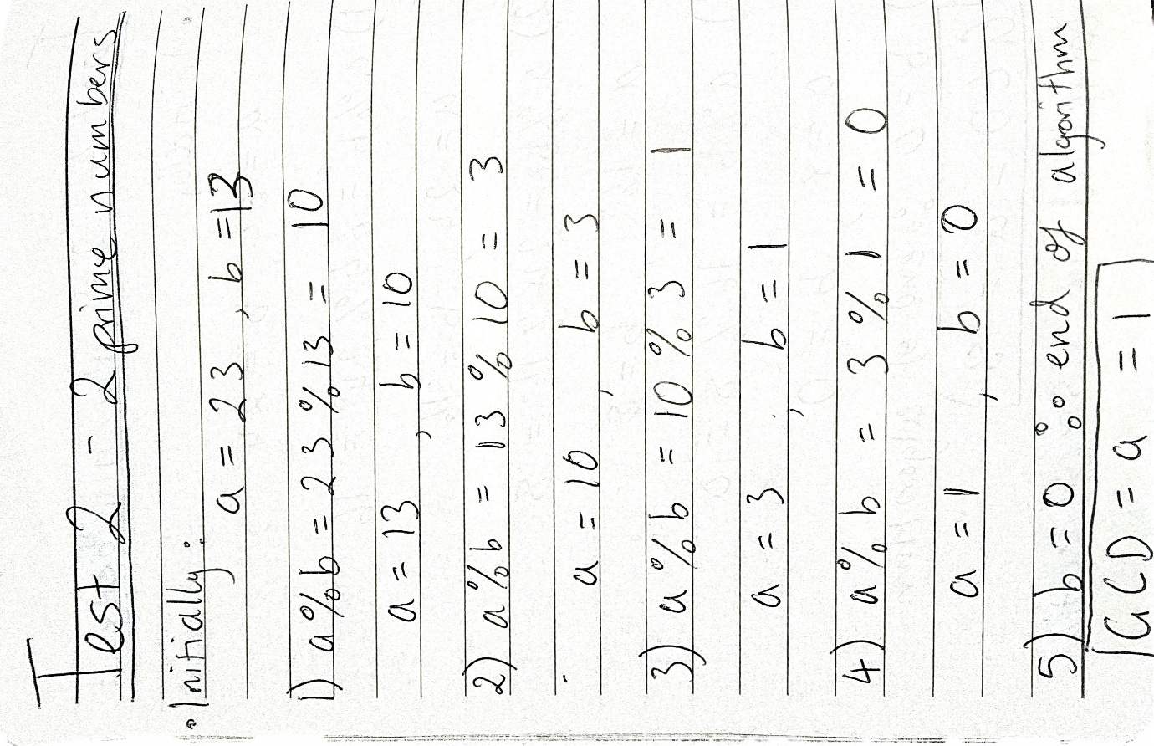
Test 3
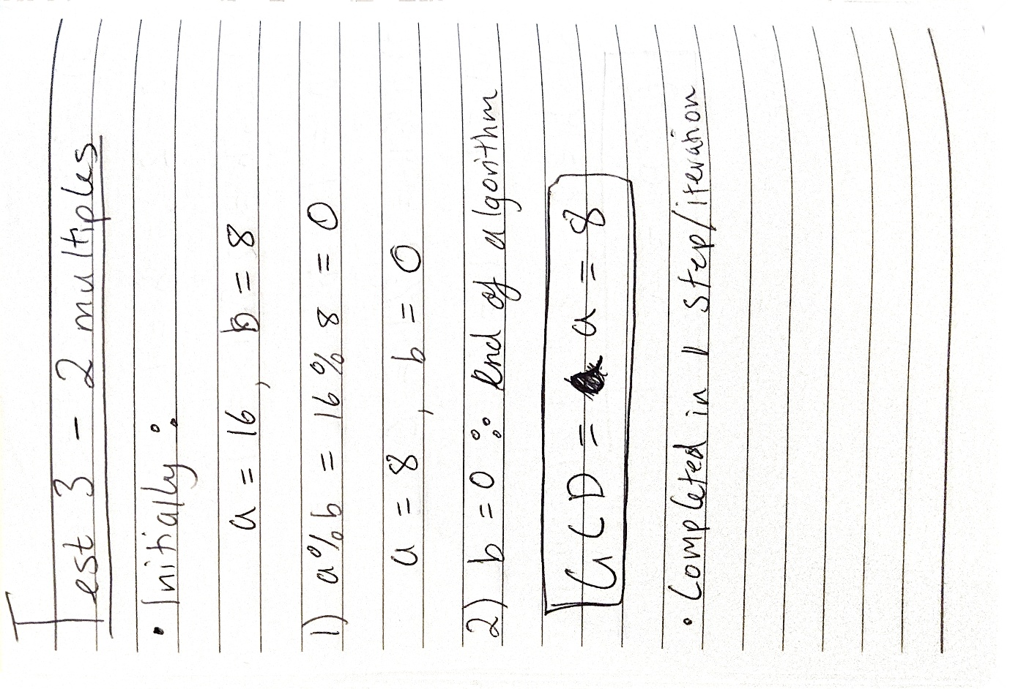
Test 4
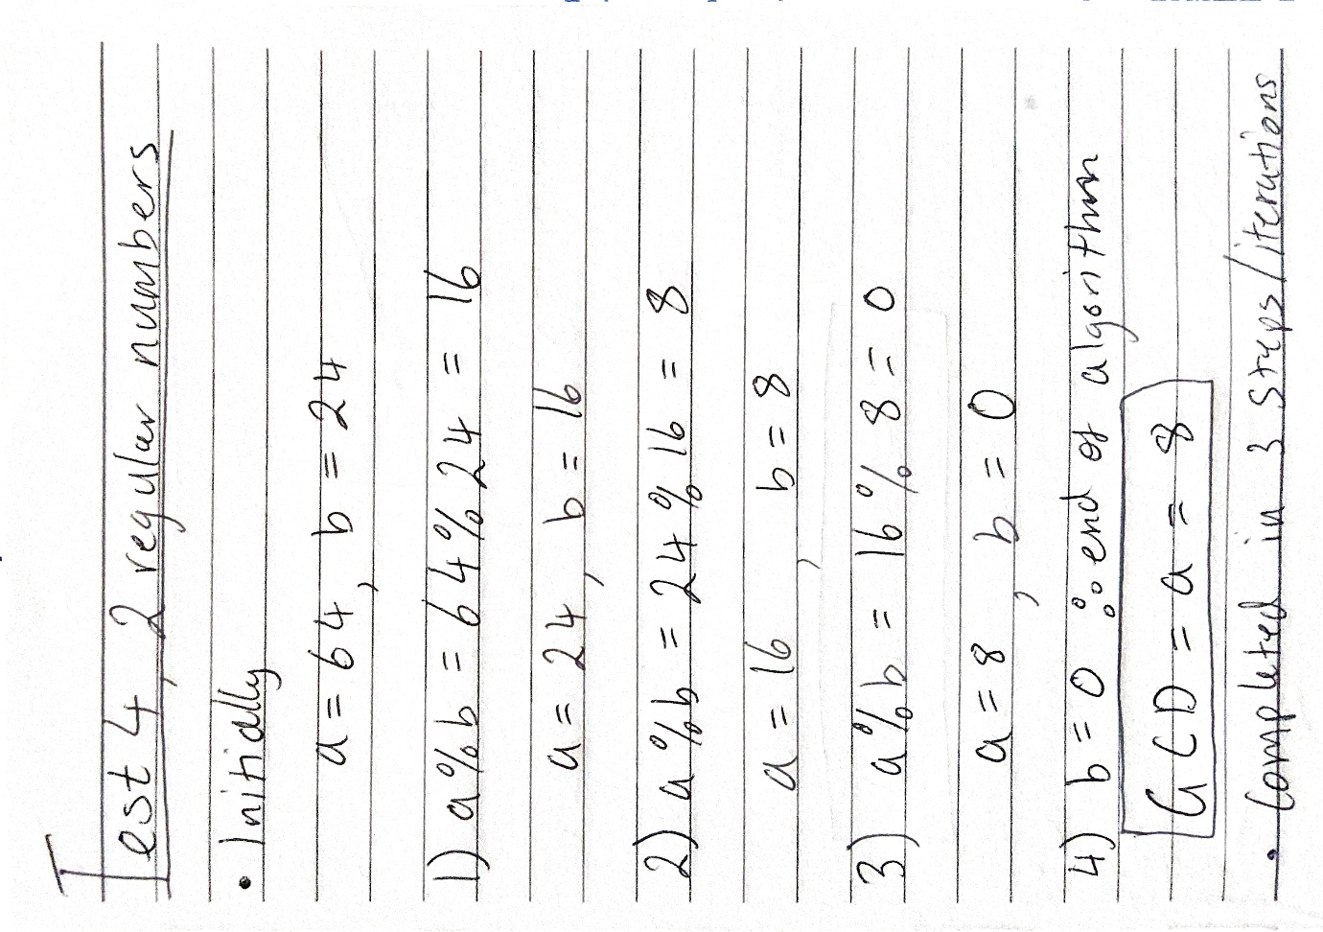
Console:
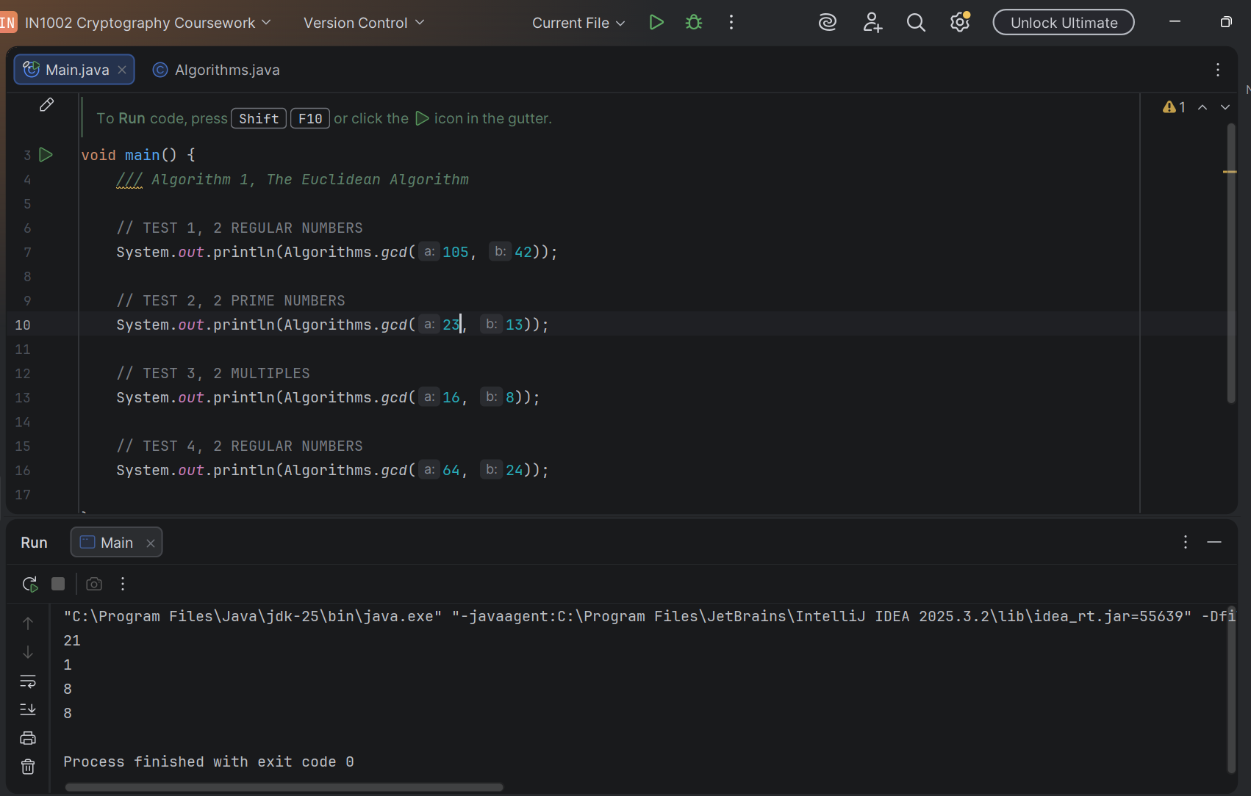
- The time complexity of this algorithm is O(log(min(a, b))), as the value of a and b grow larger, the algorithm must complete a minutely larger number of instructions. This increase is proportionally to the logarithm of how large the smaller number between a and b is. This result is because of the modulus operator that cuts down the size of a and b in large amounts per operation, causing larger values of a and b not to have a substantial impact on the number of instructions.

Algorithm 2: Generating Primes (Sieve of Eratosthenes)
- The Sieve of Eratosthenes is an algorithm that generates all the prime numbers less than or equal to a given number, we can call this number n. The algorithm starts with a sequence of natural numbers, going from 2 all the way to n. It then finds the prime numbers by eliminating all non-prime (composite) numbers within the sequence, doing this by cancelling out multiples of a continuously updated base number we can call p.
What this means is that the base number is made to start from 2 and then all multiples greater than p (2) but less than n are cancelled out. The base number, p, is then updated by taking the very next uncancelled number after 2. This continues till p is greater than √n, upon which the algorithm can terminate. The result is an array of cancelled and uncancelled numbers, the uncancelled numbers will all be the prime numbers between 1 and n.
- The precondition of the algorithm is that n > 1, where n is positive. This is because below 2 there are no primes to find (both 0 and 1 are not prime), therefore, they cannot be used as the limits. The postcondition of the algorithm is a sequence/collection of values consisting of only prime numbers, all of which are greater than 1, but less than or equal to n.
- The reason why crossing multiples out leaves just the primes is because definitionally, primes have only 2 divisors, 1 and themselves. Crossing out multiples allows us to eliminate numbers that violate this definition, which would be composite numbers. Mathematically, the algorithm would be unable to eliminate the prime numbers due to the fact they have no multiples reachable by eliminating multiples, except 1 which is not included as a base in the elimination and themselves, which are not eliminated when eliminating multiples. Therefore, we can guarantee that the remaining numbers are prime.
As for why all composite numbers will be eliminated, this is because all the composite numbers have at least one prime factor less than √n. This is important as these prime factors are the mechanism we use to eliminate the composite numbers. In the loop from 2 up to √n, we will ensure to eliminate every composite number less than or equal to n because the prime factor of every composite number in this range will have been reached as a base for eliminating multiples, causing the composite number itself to be eliminated.
- Code snippet (long code)
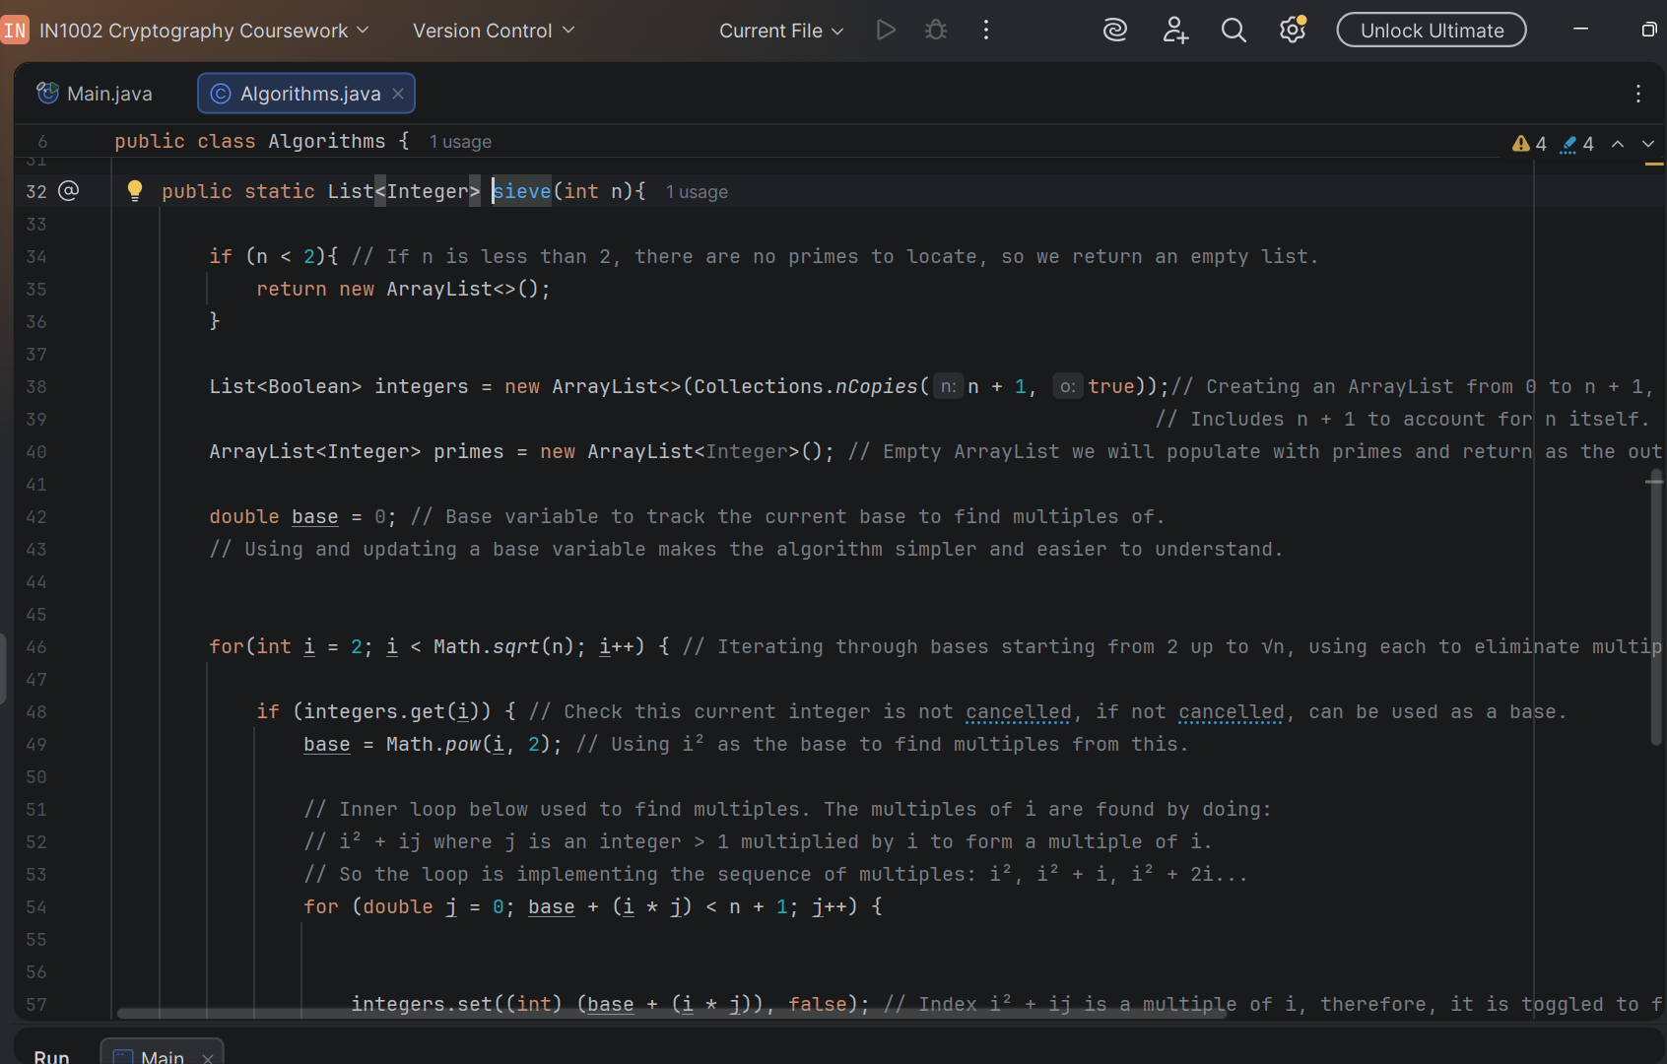
- Test 1, n = 10

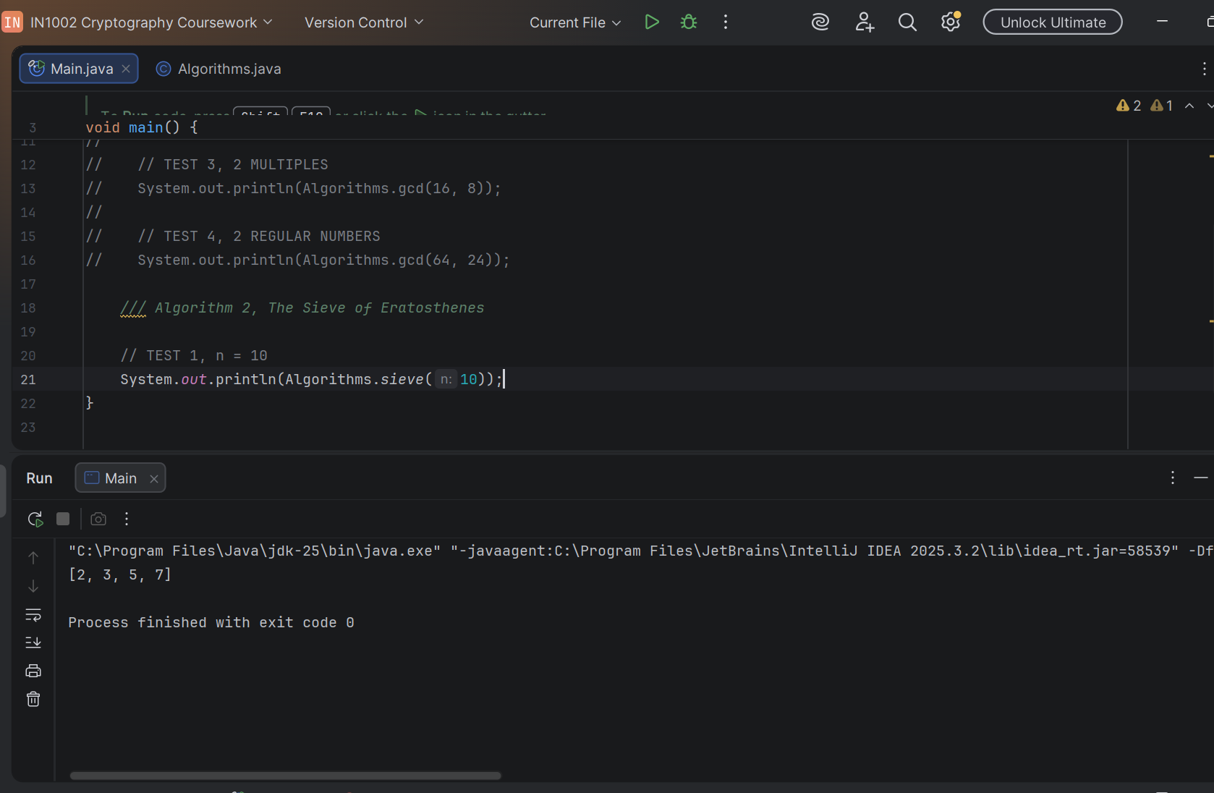

Own working as known list of primes up to 10:
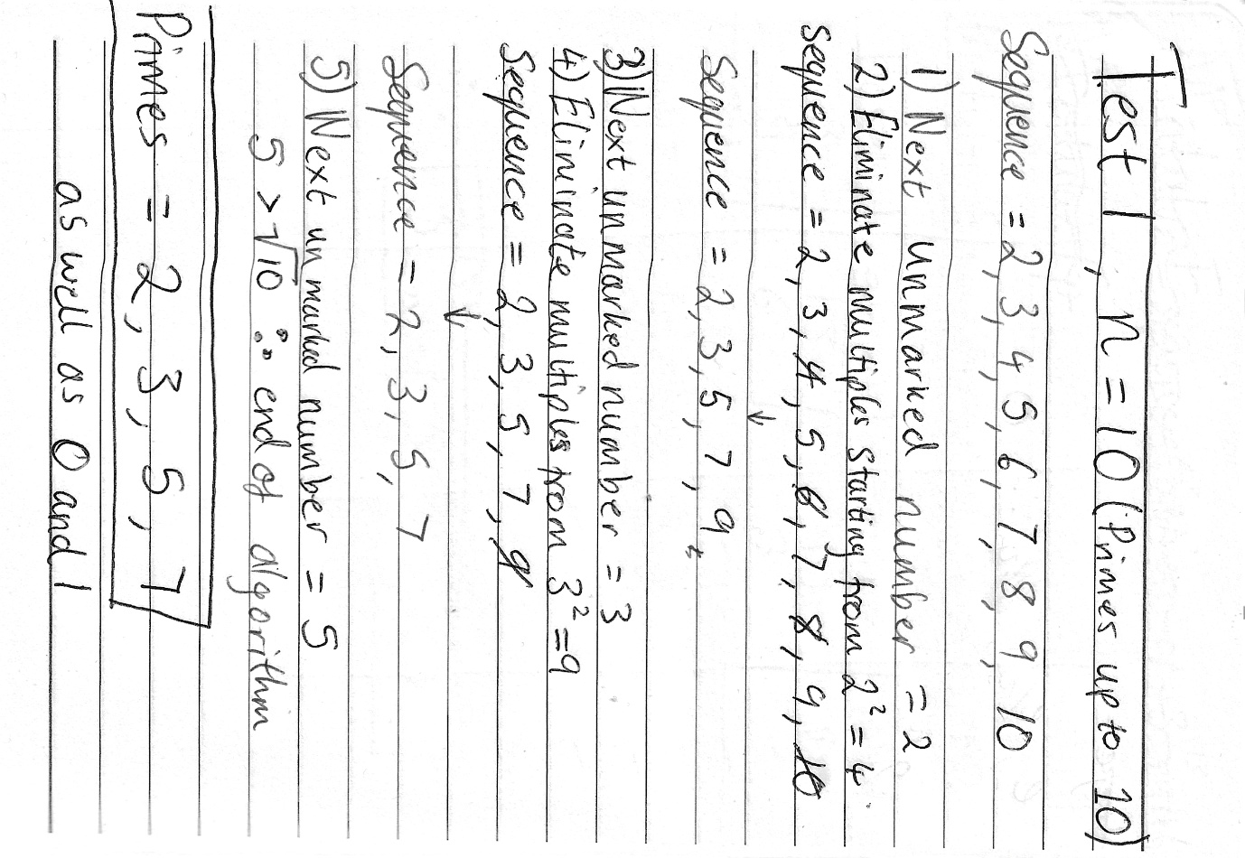

Test 2, n = 50

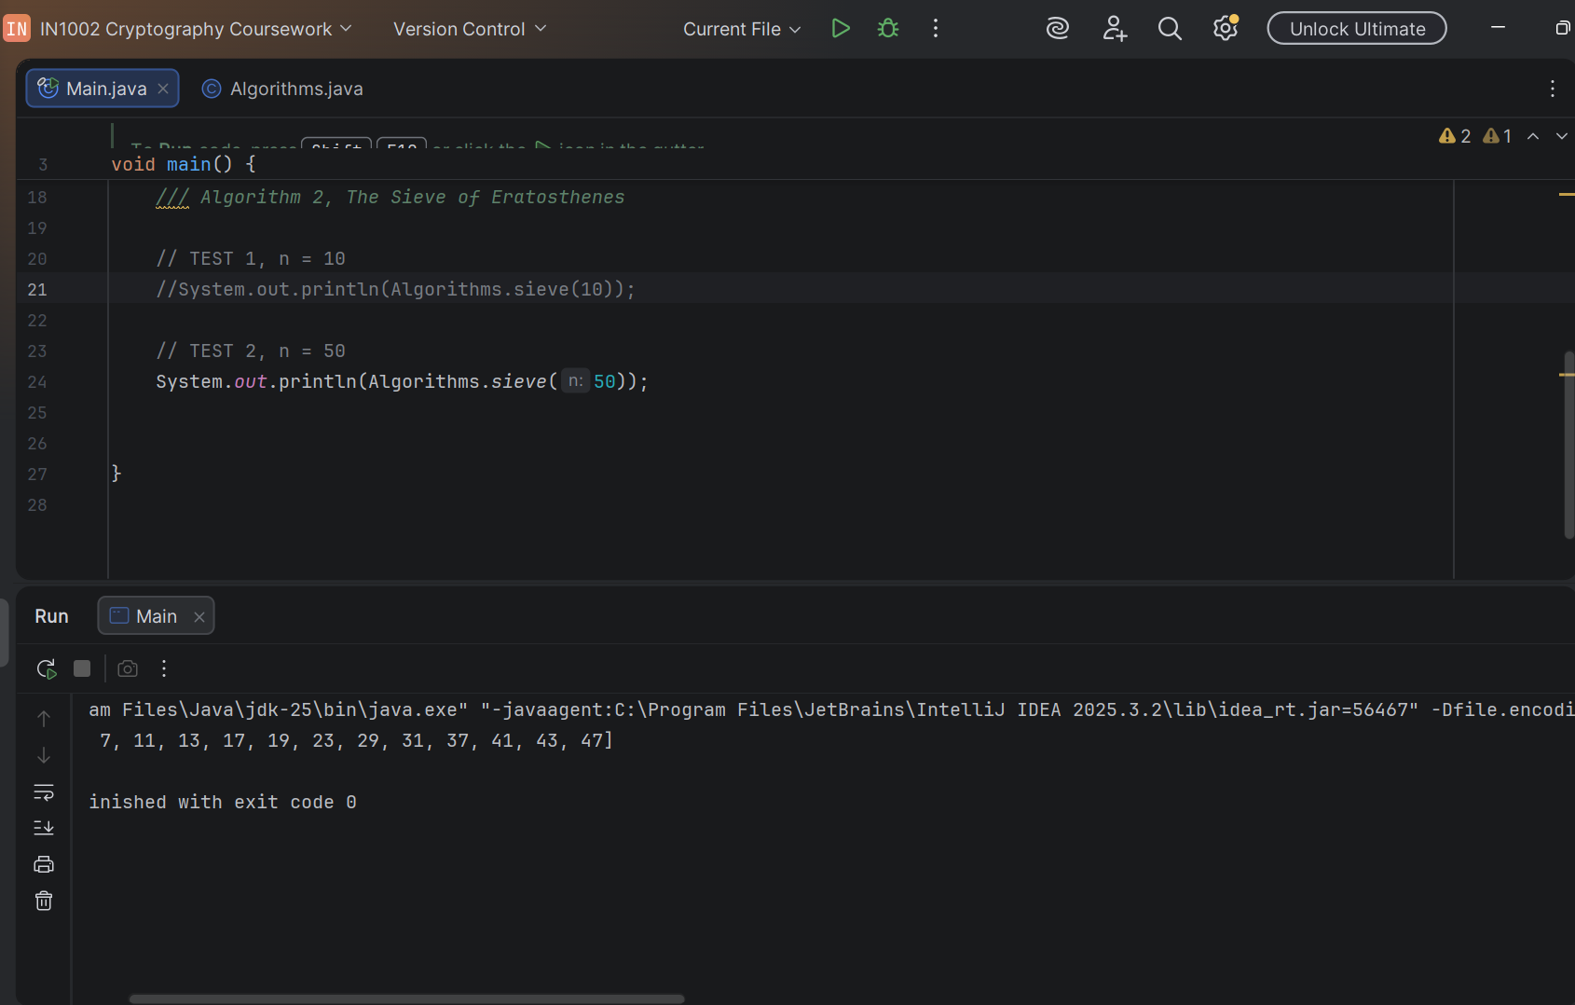

Known list of primes up to and including 50

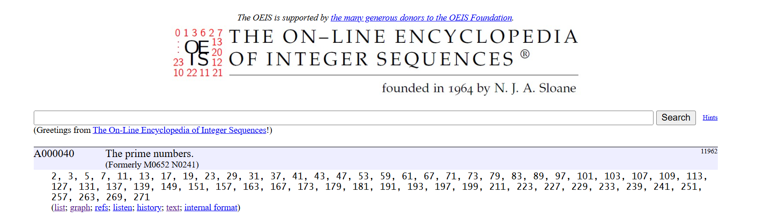
(The on-line encyclopedia of integer sequences, https://oeis.org/A000040/list, last accessed 3/8/24)

Test 2, n = 100

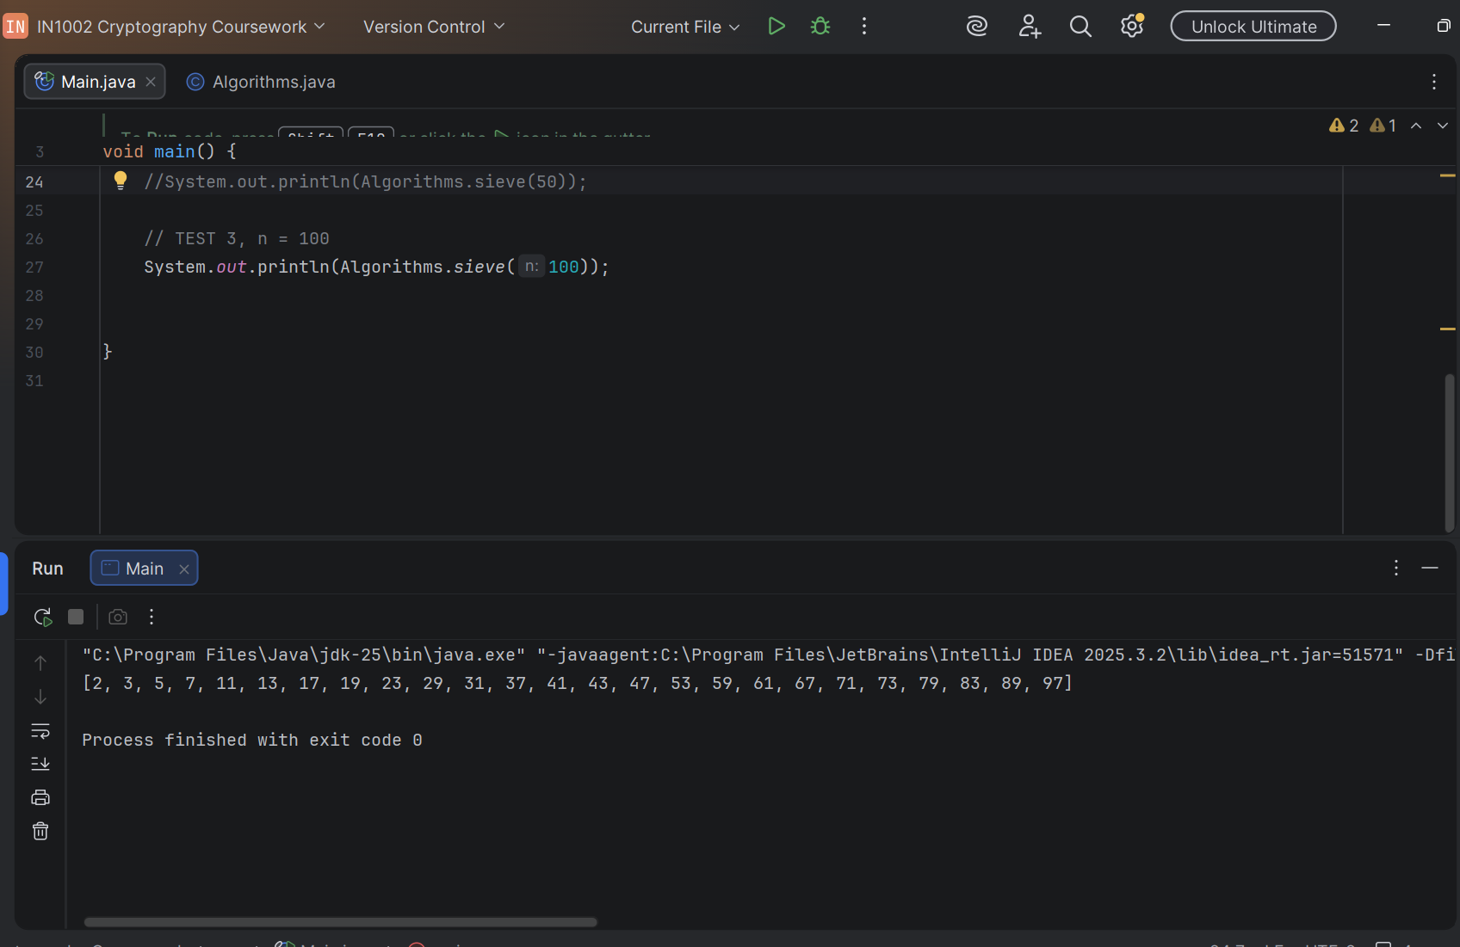

Known list of primes up to and including 100


(The on-line encyclopedia of integer sequences, https://oeis.org/A000040/list, last accessed 3/8/24)

- We only need to eliminate multiples up to √n because of the concept brought up previously, each of the composite numbers will always have a prime factor (we can call p) less than or equal to √n (p ≤ √n).
This can be derived using some algebra. Take c to be a composite number, and p and q to be the numbers multiplied to form it. p is the smallest prime factor of c. The formula for a composite number (c) is:

c = p * q
with
p ≤ q

(where p and q are both integers, and the smaller of the two is prime)

Multiplying both sides by p:

p x p ≤ p * q
This is the formula of our composite number, so substitute:

p² ≤ c

Take the square root:
p ≤ √c

Now, we know that the composite numbers must be less than or equal to n.

c ≤ n

Taking the square root:

√c ≤ √n

By the transitive property:

If p ≤ √c
and √c ≤ √n
then p ≤ √n

Using this information, we can conclude that every composite number c ≤ n will have a prime factor p ≤ √n. Therefore, to cancel every c that is ≤ n we only need to cancel the multiples of primes up to and including √n. Any higher than this, and the work will be redundant.

- The time complexity of the algorithm is O(n log(log(n)) ). We can derive this using some algebra again. To start, the multiples of p go in the sequence p, 2p, 3p, 4p… . To satisfy the problem, the sequence continues without exceeding n. This means that the k^th term of the sequence, where k is an integer, is going to be:
k * p ≤ n

Dividing both sides by p, w e find that the largest value of k must not exceed n/p in order to have the last item of the sequence be ≤ n. We must also take the floor of n/p to ensure that k remains a whole number:

k ≤ floor(n/p)

k being ≤ n/p tells us that for a prime p, if the highest multiple can only be less than or equal to n/p, then, we can conclude that there are a total of roughly n/p multiples for each prime.

~ n/p multiples for each prime p ≤ √n

Therefore, if we are cancelling the multiples of each prime up to and including √n, and we take cancelling each multiple to be a single operation by the algorithm, the total amount of operations completed by the algorithm for a limit of n is the sum of the total number of multiples for each value of p. Each multiple of each value of p is an operation, therefore, we sum the total number of multiples of every p to know the total number of operations:

Each p has n/p multiples, where each multiple represents an operation. Therefore, n/p operations for each p.
Summing the amount of operations for each p we get:
Total operations = Σ(n/p)

Factoring out n:

Total operations = n(Σ(1/p))

Now using a mathematical identity, we know that the sum of reciprocal primes up to a limit of √n approaches log(log(√n)), known as the prime harmonic series.
Now log(√n) ≈ log(n) because log(√n) = log(n^1/2) = 1/2log(n), meaning the square root only shifts log(n) by a small, constant factor of ½ . When calculating the time complexity, we can ignore this, getting us to log(√n) ≈ log(n) and, as a result, log(log(√n)) ≈ log(log(n)).
Therefore, for our last step, we can substitute Σ(1/p) = log(log(n)) to get:
Total operations = n(log(log(n)))
Therefore: Time complexity = O(n log(log(n))) as required.

Algorithm 3: Modular exponentiation

- Imagine the equation b^{e} mod m, where e is a very large number. If we take a value like e = 750, we get the question b⁷⁵⁰. In a regular programming language like Java, attempting to compute b⁷⁵⁰ will cause an error. This is because the value of b⁷⁵⁰ is too large to store using any given datatype such as int, float, double etc. To remedy this, the algorithm avoids calculating b^{e}, but instead breaks b^{e} mod m into several smaller sub-problems. On a high level, the exponent of e of b^{e} is converted to binary and every time we find a bit that is 1 in this exponent, we multiply its base b^{k} mod m in by our running total variable, result, to keep track of the remainders of all the active bits so far (bits that are 1 in the exponent’s binary representation). In each of these smaller sub-problems, base is multiplied by itself to move up a place in the binary representation of the exponent (b^{2^0}, b^{2^1}, b^{2^2}… b^{2^log} ₂^{(e)}) and exponent is halved each time to shave off the least significant bit (already checked). This continues till the exponent is smaller than 0 or equal to 0, up on which we have fully calculated b^{e} mod m
An example sub problem in English would be:
If bit value of the exponent at the index 2 of it’s binary representation is 1, what is the remainder of the result of doing our previous result multiplied by the integer value of the exponent’s bit at index 2 (given as base^{2^2} mod m)?
This looks like:
result_{new} = result_{previous} * base_{i} (mod m)
where i is the total amount of iterations of the loop so far, serving as the index of our current position in the exponent in binary representation, and base_{i} = base^{2^I} mod m.
This solution takes the modulus at every step of the algorithm to keep the result small. This works because the modulus keeps the values smaller than m, allowing them to be more manageable and preventing bit overflow.

- For preconditions, the value for the modulus m, must be greater than 1 (m >= 2). This is because the modulus by 0 of any value is undefined because any number / 0 is undefined and the modulus by 1 of any value is always 0 as 1 divides every number cleanly. Another precondition is that the language must be able to store numbers roughly the size of m, because all numbers modded by m will only take on values from 0 up to and including m - 1. So, in this case, the language must be able to store numbers roughly the size of m. In a similar way, the language must be able to store numbers nearly the size of m² temporarily. This is because when the algorithm performs base x base (mod m), base x base can be nearly the size of m². Therefore, the language must be able to store a number around m² in size.
Furthermore, m cannot exceed 46340. This is a circumstantial precondition, our implementation is using int, and therefore, there is a limit on the largest number we can compute using this datatype. This is the greatest integer we can store using int that will still allow us to work with a number that is nearly m² without causing an error.
For postconditions, the variable result will hold the exact remainder of b^{e} divided by m as given by b^{e} mod m, even when e is a very large number.
- Taking the modulus at each step of the algorithm still gives the same answer as once at the end because of a particular identity in modular arithmetic:

(a x b) mod m = ((a mod m) x b mod m)) mod m

This identity is proving that applying one mod operation after multiplication is the same as applying a mod to each factor of a multiplication, multiplying them and then applying a mod at the end. Either equation used produces the same answer to a problem like b^{e} mod m, and therefore, our method of taking mod at each step is equally as valid as multiplying and then taking the mod after.
This identity is key to the functionality of the algorithm, if we look at b^{e} mod m, we can represent it as a sequence of multiple multiplications reduced at the end:

b^{e} mod m = (b^{2^0} x b^{2^1} x … b^{2^i} ) mod m
where i is the index of the last bit multiplied ins.

This equation means we perform a sequence of multiplications that lead to a large number (b^{e}) and then take mod m at the end, which is exactly the problem we are facing. However, the identity means we can do:
b^{e} mod m = (b¹ mod m x b² mod mx … b^{2^i} mod m) mod m

(Which is the same as performing a sequence of multiplications that lead to a smaller number and take mod m at the end) and still be doing the same thing. In using the identity, we go from many repeated multiplications to get an astronomically large number and then applying the mod m at the end to get our solution, to doing many repeated multiplications to get a much smaller number and applying the mod m at the end to get our solution. The second way avoids needing to compute a very large number, making finding b^{e} mod m possible.
- Code snippet (code too long):
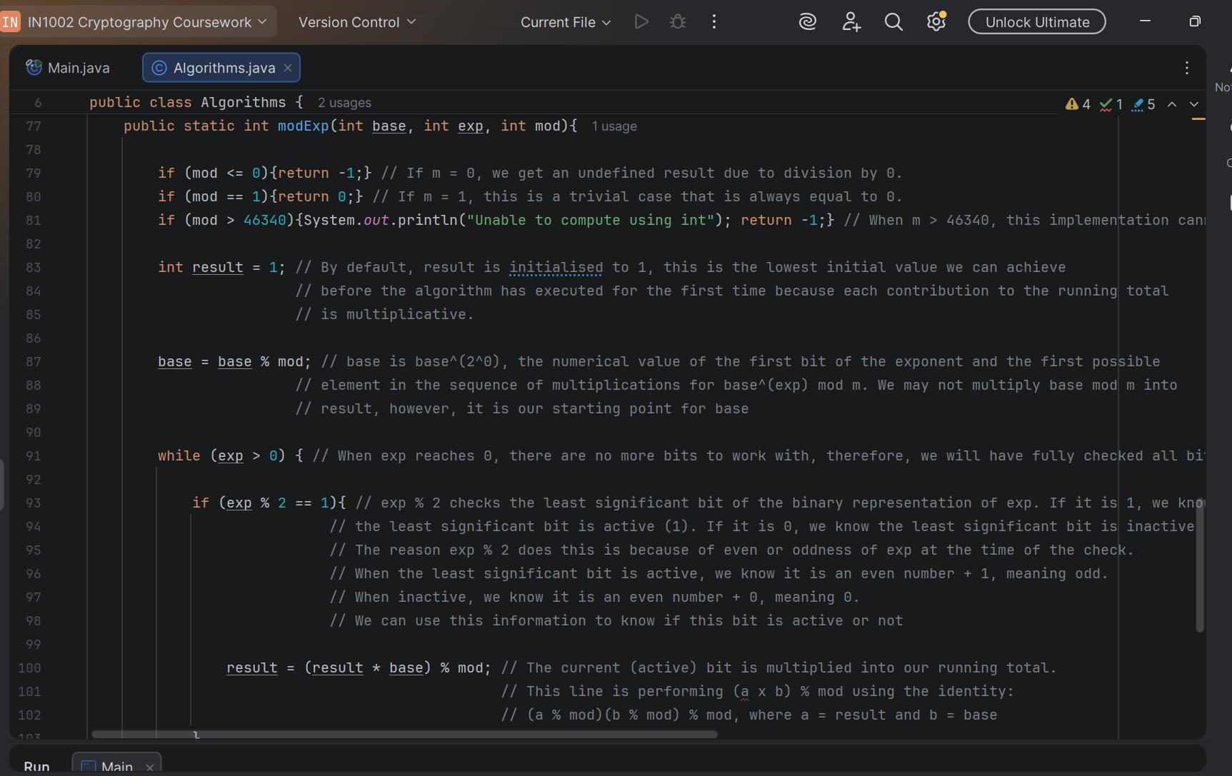
- Traced algorithm:
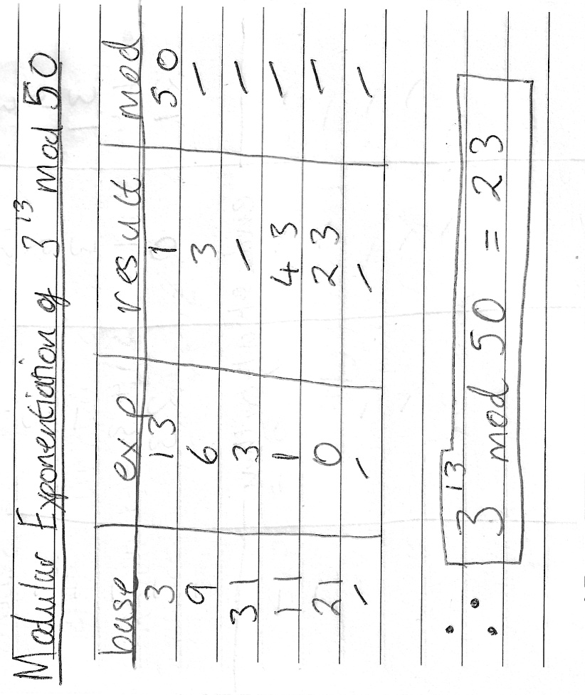
- The complexity of the algorithm is O(log e), meaning that the amount of work or instructions to complete grows logarithmically relative to the size of e. This is substantially slower growth relative to O(e) and offers significantly faster computation at large values of e than O(e).
The reason we have O(log e) as opposed to O(e) is because of our approach to looking at the binary representation of exponent. Every iteration, the size of our exponent is roughly halved, and we check every bit of the exponent before it is halved. The algorithm will only continue up until the exponent is 0 in binary, which means shifting right as many times as the number bits we need to make up the exponent in binary (we need to shift all the bits into the fractional part so that they are truncated in the integer division, meaning we need to shift a binary number of 4 bits, 4 times to the left in order to truncate all its bits and make it 0). Therefore, the number of bits used to form the exponent in binary is the total number of operations to compute an output, given by:
Total operations = log₂(e)
where log₂(e) is the number of bits in the binary representation of e
An example would be 3¹³ mod 50. We require 4 bits to make up 13 (1101₂) and therefore, 3¹³ mod 50 can be computed in only 4 iterations.
Algorithm 4: The Diffie-Hellman Key Exchange

- The Diffie-Hellman Key Exchange algorithm is an algorithm designed to allow two parties, unknown to one another, to share a secret over an insecure channel. These two parties can share a private value known only to one another, despite the presence of eavesdroppers on a public channel. 2 people we can name Alice and Bob are on a channel where anything they transmit is public to anyone listening. They will agree on a base g and a prime p, where p is usually a very large number for the sake of security. Eavesdroppers will know g and p (agreed on over public channel). Alice and Bob will then choose secret powers a and b respectively and compute g ^{secret power} mod p. Once they have computed their own remainders, they transmit this over to one another. By now, eavesdroppers will know g, p, A = gª mod p (Alice) and B = g^{b} mod p (Bob). Upon receiving Bob’s remainder, Alice will raise this to the power of her secret number (Bª mod p) and vice-versa for Bob (A^{b} mod p). Alice and Bob will then have computed the same, shared, secret value.
The paint mixing analogy explains this more simply. Imagine two people, Alice and Bob, agree on a common colour. They then choose secret colours and individually mix their common colours and secret colours to form two new mixtures (common colour + secret colour = mixture). They then, over this public channel, will share their individual mixtures to one another (Bob receives Alice’s colour, Alice receives Bob’s colour). Upon receiving the opposite party’s mixtures, both parties will mix in their own secret colours again (secret colour + other party’s mixture) to form a new, shared secret colour that is only known to Alice and Bob.
- For preconditions: Our value for g must be a primitive root modulo p. This means that for every number coprime to p (so of the set {1, 2, 3…p-1}) there is at least one corresponding power k that generates that number. So for every value coprime to p (p’), there exists a value k, of which g^{k} mod p = p’.
For our value of p must be prime. This is because we require all numbers from 1 to p – 1 to be coprime with p and we need to be able to generate any one of these given numbers by raising our base g to any power. Furthermore, p must be large, specifically at least 2048 bits long, to make the range 1 to p – 1 very large. This allows the final secret to be safe from brute force attacks.
For postconditions, our output is a shared secret number, more simply, an integer, that is known only to the two parties transmitting over the public channel, despite eavesdroppers listening in.
- The reason Alice and Bob arrive at the same values after the exchange is complete is due to a particular identity derived from the same as the one used in Algorithm 3:

(gª mod p)^{b} mod p = (g^{b} mod p)ª mod p = g^{ab} mod p = g^{ba} mod p

This is an important identity, because it means that so long as the base g and prime p transmitted over the public channel are the same Alice and Bob can achieve the same answer no matter the order they exponentiate each other’s equations. We can derive this.
This equation comes from:

(x * y) mod m = ((x mod m) * y mod m)) mod m

But in the most general case:

(x)^{k} mod m = (x mod m)^{k} mod m
Initially, we have (by the property of commutativity):

g^{ab} = g^{ba}

This factors out into (using exponent rules):

(gª) ^{b} = (g^{b}) ª

From here, take gª and g^{b} to be numbers a and b, therefore, we substitute them in:

x = gª
y = g^{b}
m = p
k = b
So:
(gª)^{b} mod p = (gª mod p)^{b} mod p

By the commutativity of exponents, we get:

(g^{b})ª mod p = (g^{b} mod p)ª mod p

Again, this tells the core of the Diffie-Hellman exchange. It means that there is a way for Alice and Bob to transmit a secret value that is difficult to reverse engineer and solve for without their also secret values of a and b.

- Code:
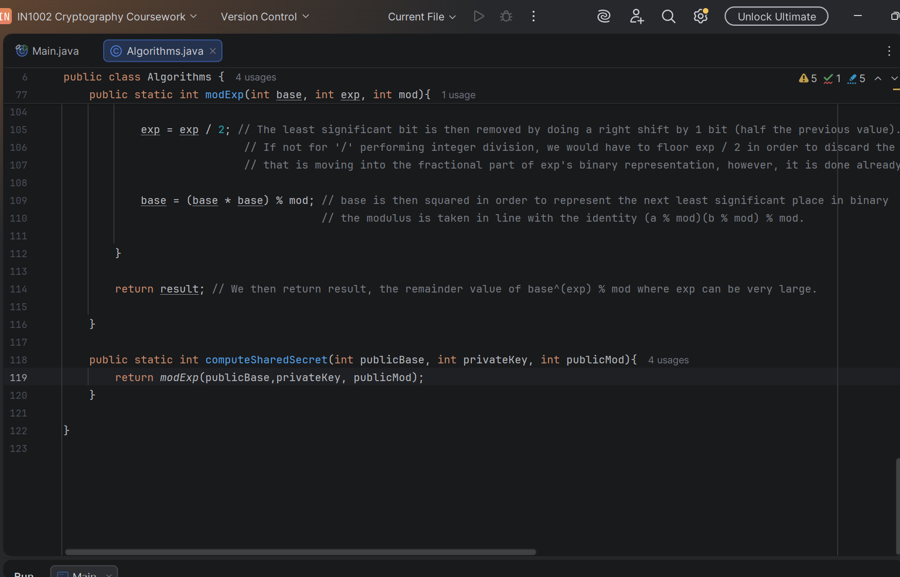
- Test Scenario
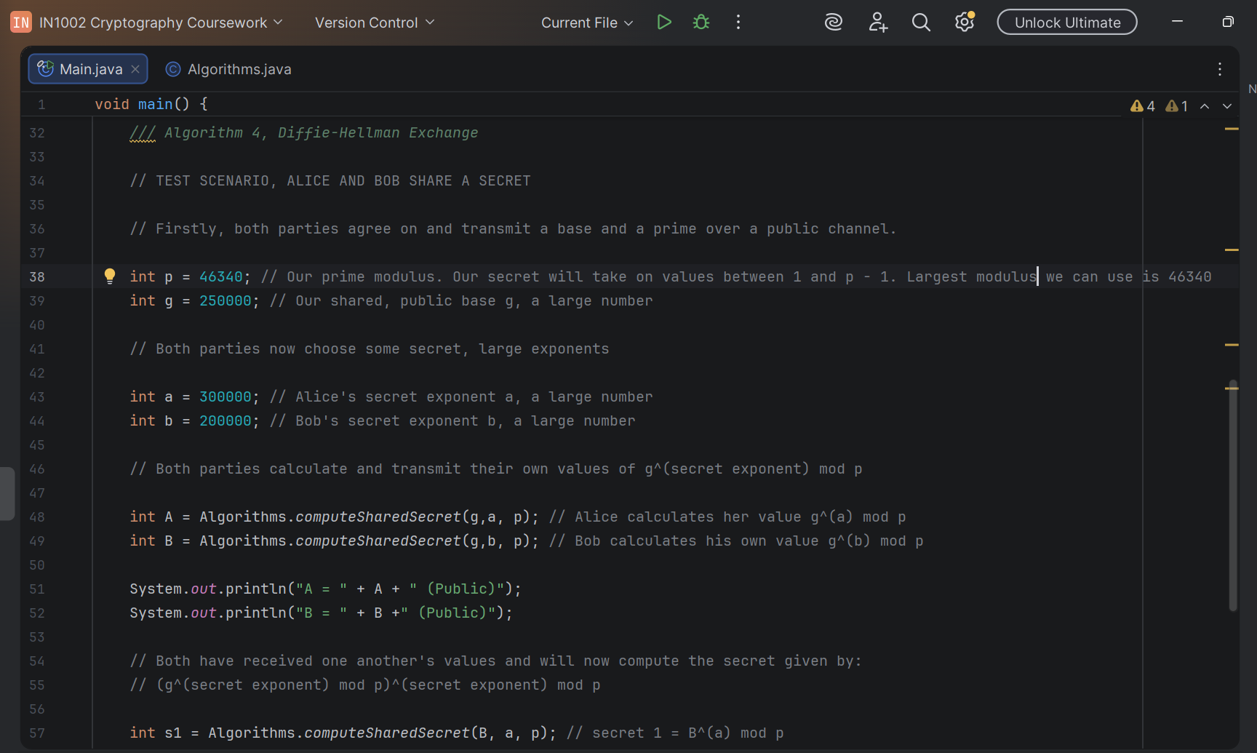
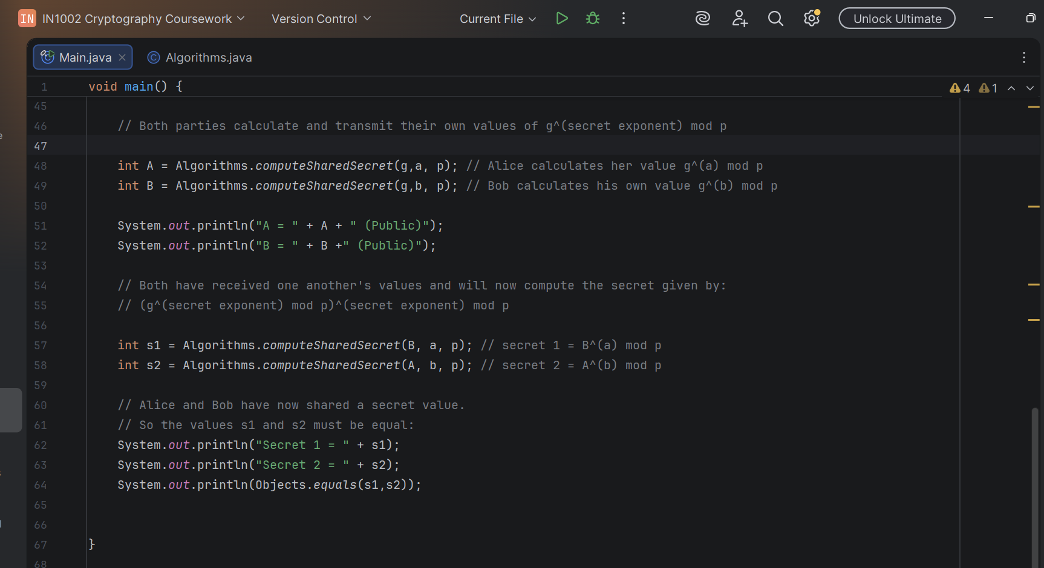
Console output:

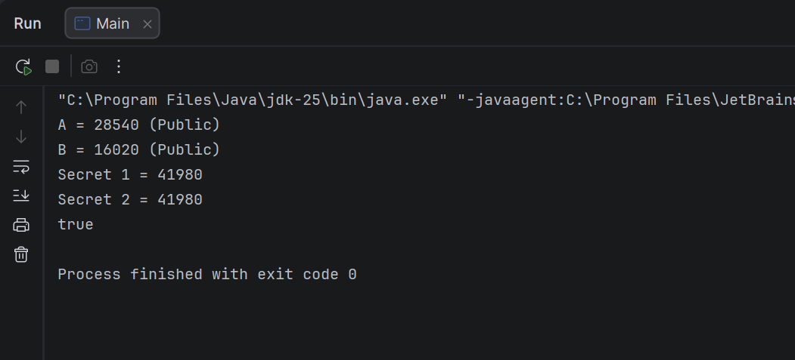

- The protocol itself is intrinsically secure due to its resistance to reverse engineering. When an eavesdropper listens in, by the end, they will have learnt about g, p, A = gª mod p and B = g^{b} mod p. To solve for the secret, the eavesdropper will need to find both a and b.
Calculating the secret S = g^{ab} mod p = g^{ba} mod p is very fast using modern algorithms. The problem lies in trying to calculate a or b, because if p, a and b are large, with the information presented, it would take even a supercomputer an unreasonable amount of time to reverse engineer the secret. This is because g^{ab} mod p = g^{ba} mod p is a one-way function. It is very easy to compute, but very difficult to reverse engineer with the information provided, which we call the discrete logarithm problem. Therefore, the secret itself is mathematically secure, there is no efficient algorithm to solve the discrete logarithm problem, and a brute force approach can take easily more than a billion years to check against all possible values the secret value could have taken on between 1 and p – 1.
Reflection
As it relates to the algorithms building off one another, the first algorithm, Euclid’s GCD algorithm does not seem to be used to build other algorithms in any meaningful way, except verifying the coprimality of integers smaller than the prime p. Similarly, the Sieve of Eratosthenes is not used to implement any of the other algorithms, however, an implementation of the Diffie-Hellman algorithm can use this algorithm to find large primes to use as values for p. The Modular Exponentiation algorithm is used directly to build the Diffie-Hellman algorithm due to the requirement to compute gª mod p and Bª mod p for very large values of g, a, B and p. This algorithm is used as a subroutine inside of the Diffie-Hellman algorithm to compute these expressions.
Efficient algorithms matter in cryptography because of the use of very large numbers. Computers struggle to store and compute expressions that use large numbers. Therefore, algorithms that can compute expressions and deal with very large numbers in much fewer steps than the usual process can turn nearly intractable problems into easily computable expressions.
The algorithm I found to be most elegant was Algorithm 3, the Modular Exponentiation Algorithm. I think that the elegance comes in the sequence of substitutions for a and b themselves being values a mod m and b mod m. Furthermore, the interpretation of the identity that proves that computing the large exponential we cannot store and taking the mod after is the same as computing its constituent factors’ remainders, multiplying and then taking the mod after are the same thing is very elegant because it opens many doors in cryptography to compute large numbers even on modest hardware.
AI assisted me by helping to me get a grasp of the algorithms, especially the theoretical, mathematical side. This is because the algorithms’ implementation tended to reach into mathematics I had not reached yet and so did not understand (Algorithms 3 and 4). Or I plainly did not understand the mathematical idea behind it. AI helped greatly in this process to help me to gain a very good understanding of each algorithm, both practically using given inputs and outputs and theoretically in how the mathematics worked. This gave me the confidence to write about and explain to others about each of the algorithms.

AI Acknowledgement
To grasp and understand all 4 algorithms, I used a combination of AI tools, namely Claude by Anthropic, ChatGPT by OpenAI and Gemini by Google. Most of my use of these tools was to gain a practical understanding as well as to clarify and interpret the theory behind the algorithms in the short time I had. I used these tools when I lacked understanding of what I was reading, namely areas of mathematics I had not yet explored.
An example of an incorrect AI output was when discussing the property:
(a×b) mod m = ((a mod m)×(b mod m)) mod m.
The AI (Claude) had said:

(a×b) mod m = ((a mod m)×(a mod m)) mod m

Instead of the correct:

(a×b) mod m = ((a mod m)×(b mod m)) mod m

I was able to correct the AI upon which, it corrected the formula and gave correct outputs again.

I verified my final submission by cross-referencing my information between all 3 AI tools. I did this to ensure that there was continuity in the information they were providing me. After that, I cross referenced the information to non-AI tools (I.e. Mathematics websites and resources) to ensure that the AI was not providing false information or getting information from non-existent sources (AI hallucination).

